The Grizzly Family Bear Book
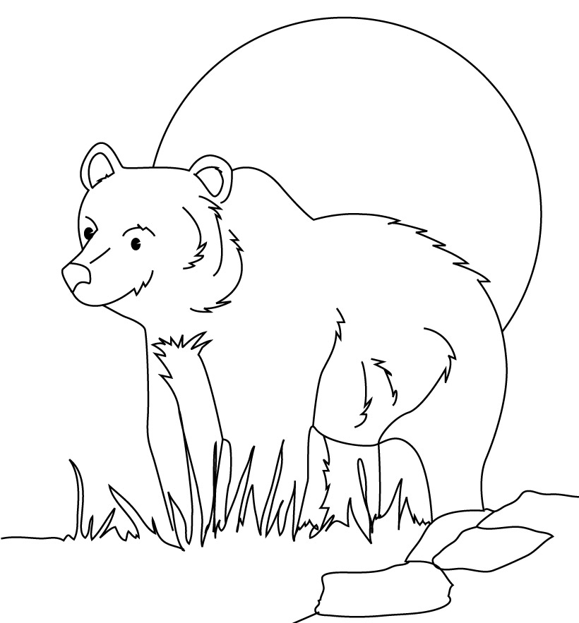

Name:____________ Class:____________

Vocabulary
Carcass | n. | The body of a dead animal
Caribou | n. | A deer-like mammal that lives in the arctic; reindeer
Aggressive | adj. | doing something with a lot of energy; wanting to attack
Dominance | n. | Showing that you are better
Subservience | n. | Showing that you are weaker
Tundra | n. | The cold treeless land in the arctic
Wilderness | n. | Place where no people live
Abundant | adj. | Having more than you need
Territory | n. | The area that belongs to an animal
Wariness | n. | Carefulness; being watchful

Write the best vocabulary word under each picture.
1. | 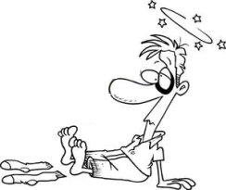 | 2. | 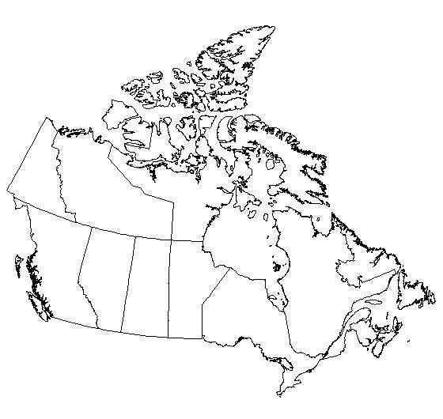 | 3. | 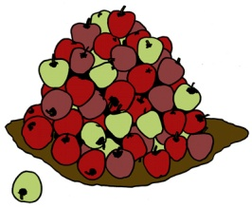
 | ______________ |  | ______________ |  | ______________
4. | 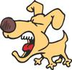 | 5. | 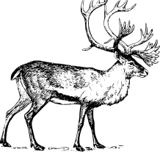 | 6. | 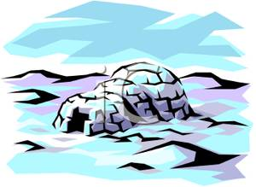
 | ______________ |  | ______________ |  | ______________

Spelling

Write the best spelling word for each sentence.
1. | My teacher likes to ___ all the rules. | ______________
2. | I will ___ money in this letter to my mom. | ______________
3. | I don’t ___ with others. Be your own good. | ______________
4. | China will ___ in a war against Japan. | ______________
5. | Did your mom ___ you to like math or do you really like it? | ______________
6. | Those bottles ___ preserved monkey hands. | ______________
7. | I did not ___ the exam. I didn’t have time. | ______________
8. | I want to ___ my British pounds for euros. | ______________
9. | One ___ is “When in Rome, do as the Romans do.” | ______________
10. | We will ___ class by twenty minutes. | ______________
11. | When in public, ___ yourself properly. | ______________
12. | Do you have a ___ with eating garbage? | ______________

Answer the questions with one-word answers.
13. | What is your excuse for not bringing your homework? | ______________
14. | What will excite the class? | ______________
15. | How many pronouns are in this sentence? | ______________
16. | What will you preserve in a jar? | ______________
17. | What prefix means “not”? | ______________
18. | What class do you propose to not have? | ______________

Bears and Seasons

Draw a picture about what bears do during each season according to our story. Then write a sentence about it.
Winter | Spring
1. | 2.
Summer | Fall
3. | 4.

Threatened, Endangered and Extinct Animals

Draw and label four different animals under each category. You may not include any dinosaurs.
Threatened | Endangered | Extinct

Famous Bears

Describe what each famous “bear” is. If you can, include a picture. If you can’t find a picture, draw one.
Bear | Description | Picture
Yogi Bear
Fozzie Bear
Bear Claw
Bear Hug
Baloo the Bear

I Don’t Believe It!

All of the sentences below are false. Rewrite the sentences to make them true.
- Bears sleep during the winter.
_______________________________________________________
- Bears eat salmon carcasses at the end of winter.
_______________________________________________________
- Bears will attack and kill an adult moose.
_______________________________________________________
- Bears come together during ground squirrel season.
_______________________________________________________
- Bears love to eat the eyes and ears of a salmon.
_______________________________________________________
- The favorite berry of a bear is a strawberry.
_______________________________________________________
- Bears need to put on a lot of muscle for the winter.
_______________________________________________________
- Michio Hoshino was killed by a moose.
_______________________________________________________

Adjectives
An adjective is any word that describes a noun. The following types of words are usually adjectives:
 | Definition | Examples
Articles
Demonstratives
Personal Titles
Possessive Pronouns
Indefinite Adjectives
Numbers

Sometimes a verb can be an adjective. In the sentence
- I wash the dog.
The word wash is a verb. If we change wash to the past participle, we can say
- The dog was washed by me.
In this sentence, washed became an adjective. The kind of grammar in sentence example 2 is called passive voice. We can also say
- The washed dog runs.
In this sentence, wash is an adjective again.

Verbs Transformed into Adjectives

In sentences one to four, change the verb to passive voice. In sentences five to seven, change the verb to an adjective as in the third example.
- I eat the banana.
_______________________________________________________
- He holds a bottle.
_______________________________________________________
- The shark bit a fish.
_______________________________________________________
- Greg chased the boy.
_______________________________________________________
- Monkeys helped the lion.
_______________________________________________________
- The spider finishes her web.
_______________________________________________________
- The pitcher throws the ball.
_______________________________________________________

Describing a Beach

Write four sentences describing the picture below. Each sentence must have at least one adjective and one adverb. Circle each adjective and put a box around each adverb.
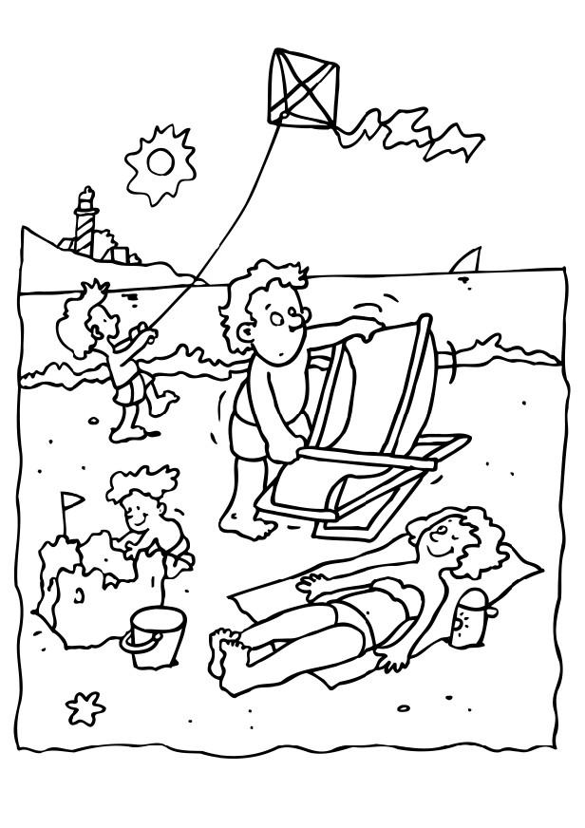
1.____________________________________________________________________________________________________________________________________________________________________________

2.____________________________________________________________________________________________________________________________________________________________________________

3.____________________________________________________________________________________________________________________________________________________________________________

4.____________________________________________________________________________________________________________________________________________________________________________

Bear Types

Choose two types of bears from the list below and fill out the information about them.
Bear Types
Spectacled | Polar | Grizzly | Kodiak
Black | Asiatic | Sloth | Sun

Bear Type:
Home Country: | Size:
Enemies: | Life Span:
Diet: | Interesting Facts:  1)  2)
Picture

Bear Type:
Home Country: | Size:
Enemies: | Life Span:
Diet: | Interesting Facts:  1)  2)
Picture

